## Agricultural production challenges

Global agricultural production is at a crossroads. On the one side, the need to produce more food more cheaply is homogenising production systems with dramatic consequences for biodiversity, ecosystems and biomes. On the other, population growth, changing consumption patterns, rising incomes and globalisation are changing what, where food is consumed. Meanwhile, global production of meat is projected to more than double from 258 million tonnes in 2006 to 455 million tonnes in 2050, whilst milk production is expected to grow from 664 to 1,077 million tonnes (Alexandratos and Bruinsma, 2012). The Food and Agriculture Organization (FAO) has estimated annual global production of crops will need to increase by 60% from 2006 levels by 2050 to keep pace with rising demand (FAO, 2016).

Potential yield gains for crops and livestock are hindered by widespread land degradation, land scarcity, and climate change, which threaten where and how much food we can produce (D’Odorico et al., 2014; Tai et al., 2014; Alexander et al., 2015; Webb et al., 2017). A review conducted for the Intergovernmental Panel on Climate Change (IPCC) suggests climate change will adversely effect crop yields post 2030 (Porter et al., 2014), and these impacts will vary regionally in response to precipitation variation and temperature change (De Pinto et al., 2016). For livestock, climate change related impacts will likely decrease meat and milk production primarily due to changing quality of forage (Chapman et al., 2012), pest/disease prevalence (Nardone et al., 2010; Bett et al., 2017) and water availability (Thornton et al., 2009; Havlík et al., 2015). Webb et al. (2017) and Bommarco et al. (2018) suggest retaining biodiversity and ecosystem services in agriculture are paramount to meeting these food security challenges.

Meanwhile, farm systems worldwide are being homogenised in pursuit of productivity goals that are at the expense of local diversity and farm-systems resilience (Tscharntke et al., 2012; IPES-Food, 2016). Reduction in diversity increases vulnerability to climatic and other stresses, raises risks for individual farmers, and undermines the adaptability of agriculture to meet future drivers of change (Thrupp, 2000).

## Agrobiodiversity is undersupplied

Agrobiodiversity (see Figure 1) can be broadly defined as all domesticated biodiversity (i.e. crops and livestock) within agricultural systems, plus non-domesticated biodiversity that interplay in various ways with the health and functioning of agricultural systems (Pascual et al., 2011). The former is declining primarily in response to farm intensification, which has eroded natural capital in many agroecosystems (Chaplin-Kramer et al., 2015; Tsiafouli et al., 2015).

Global agriculture is increasingly reliant on a limited subgroup of plant and animal diversity . Only 15 animal species account for 90% of livestock production (Villanueva et al., 2004). Just 12 plant species worldwide provide more than 70% of all human calorific intake from arable crops (Frison et al., 2012). Within these species, a declining number of breeds and varieties are responsible for the majority of production (FAO, 2015a; Gruber, 2017). Yet, the ability to grow crops and graze pastures in challenging environments, particularly those most effected by climate change, will require adaptive genetic resources. Rojas-Downing et al. (2017) suggests crop and animal diversification are the most promising adaption measures for climate change and this suggested a role for farm animal genetic resources (FAnGR) and plant genetic resources (PGR) for agriculture.

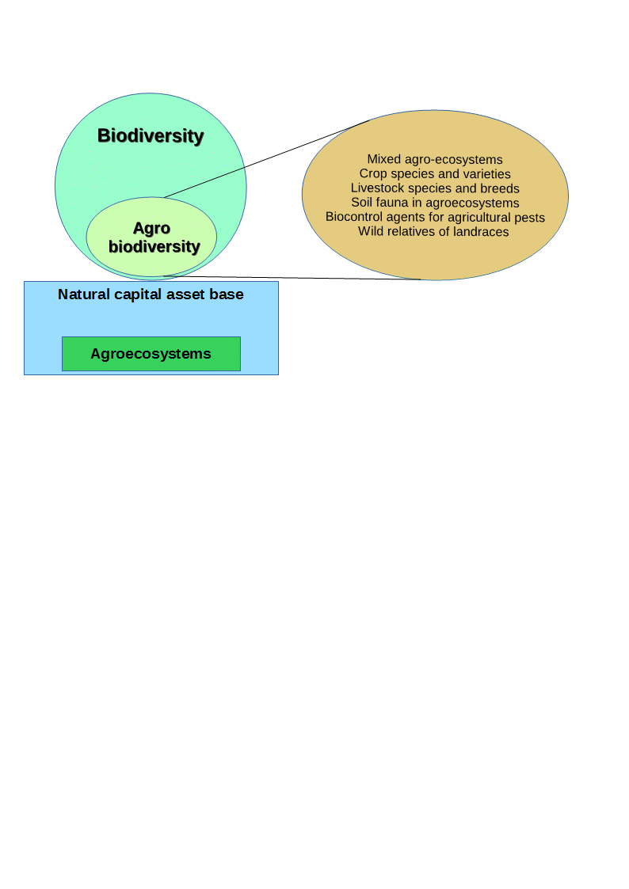

**Figure 1:** Biodiversity and agrobiodiversity are reliant on sustaining natural capital and agroecosystems. The various elements that comprise agrobiodiveristy are outlined. Adapted from FAO (2004).

FAnGR can be defined as the avian and mammalian species used for food production, while PGR comprises cultivars and their wild relatives (FAO, 2015b). Both facets of diversity are undersupplied and this can be appreciated with reference to the economic conceptual framework that suggests diversity is a public good whose value is not captured by markets. As such this element can lack an explicit value for providers (Pearce and Moran, 1994). Diversity is therefore not considered in the cost of food production and this leads to undersupply as farmers ‘disinvest’ in pursuit of profit (Pascual and Perrings, 2007; Sustainable Food Trust, 2017). The resulting market failure has homogenised production landscapes worldwide and corrective measures are necessary to supply more diversity through policies that govern food production and biological resource use (IPES-Food, 2016).

The need to conserve genetic resources for agriculture has been formally recognized by the Convention on Biological Diversity (CBD) Aichi Biodiversity Targets (CBD, 2013) and various international declarations[1]. Recent work by The Economics of Ecosystems and Biodiversity for Agriculture and Food (TEEBAgriFood) has stressed the importance of valuing natural capital in agroecosystems, and the need to invest in agrobiodiversity for future food security (TEEB, 2018). This is further stressed by The Intergovernmental Science-Policy Platform on Biodiversity and Ecosystem Services (IPBES, 2018), which suggests such investments make sound economic sense, i.e. the benefits generally outweigh the costs.

But while much work has explored the costs and benefits of preserving “naturally occurring” biodiversity, much less has focused on the supply and demand side aspects of agrobiodiversity. Work by Bioversity International (2018) has begun to offer insights by exploring the use of payments for agrobiodiversity conservation services (PACS) for the delivery of agrobiodiveristy from private land via incentives (e.g. Narloch et al., 2011, 2013; Pascual et al., 2011; Krishna et al., 2013). The thesis develops this agenda further by focusing on a key literature gap: how to improve the design of agrobiodiveristy incentive schemes for better conservation outcomes.

## Economic incentives to supply more diversity

Economic incentives can address market failures through a range of policy tools including regulation, taxation, certification, and subsides. Incentives work by influencing the behaviours of actors and firms through the alteration of market signals, and have become an increasingly popular way to address a range of environmental problems, including biodiversity loss (Tietenberg and Lewis, 2018). Market-based incentives are preferred because they offer more flexibility than ‘command and control’ policies that typically require firms to adhere to minimum standards or regulations (de Vries and Hanley, 2016). These tend to be more costly ways of insuring compliance with environmental objectives.

The advantages of market-based approaches extend to voluntary incentive schemes, such as payments for ecosystem services (PES), where landowners are rewarded for supplying ecosystem services on private lands (Farley and Costanza, 2010). While incentive instruments for biodiversity are proving more popular worldwide, funding limitation are a major constraint (McCarthy et al., 2012; Waldron et al., 2013). Moreover, buyers of conservation services (usually governments) often face uncertainty as to how the costs of supplying diversity are distributed across landowners. The conservation benefits can also vary across sites (and genetic resources). This poses challenges to the design of incentive mechanisms in being both effective and efficient at sustaining agrobiodiveristy improvements. It is therefore of interest to explore how the design of incentive schemes can be made more effective.

Globally incentive schemes specifically targeting PGR conservation are uncommon as most conservation occurs in protected areas or reserves rather than on-farm (FAO, 2010; Frese et al., 2014). Where such schemes are implemented, they generally work by providing landowners with a fixed payment (per ha) for providing conservation services (Pascual et al., 2011). Similarly, schemes for FAnGR provide fixed payments (usually per animal) to landowners for conserving rare breeds (Kompan et al., 2014). The key problem with such uniform payment schemes is adverse selection – i.e. payment levels might not actually relate to the actual costs of participation for scheme entrants, resulting in over-compensation due to information asymmetries (de Vries and Hanley, 2016). Additionally, fixed price schemes are seldom differentiated based on different value attributes of diversity or extinction risk and few target specific suppliers (agents) of conservation services. The challenge of revealing suppliers true opportunity cost, preferences for conservation contracts and overall costs/benefits from conservation investments has given rise to a range of empirical approaches that can be used to better inform policy . This thesis considers three approaches to improve conservation policy design .

Choice modelling has been a common approach to elicit landowner preferences for the design of conservation schemes and to measure willingness to accept (WTA) monetary rewards for contracts, thereby revealing cost heterogeneity (e.g. Ruto and Garrod, 2009; Greiner, 2015). Such approaches have been used to identify factors that may impact participation in schemes (e.g. contract length) and ultimately the cost of implementing schemes under specific contractual terms (Hanley et al., 2012). Alternatively, conservation auctions are an incentive based mechanism that can potentially deal with the issues of adverse selection and poor cost effectiveness by promoting price competition amongst landowners opting to supply conservation services (Windle and Rolfe, 2008; Whitten, 2017). Such approaches can be combined with optimisation modelling to maximise a certain objective function relative to various constraints, and have been shown to outperform fixed priced schemes (Rolfe et al., 2017). Lastly, decision support tools, such as multi criteria decision analysis (MCDA), have emerged to combine technical information and stakeholder preferences to appraise costs/benefits of different projects alternatives (Adem Esmail and Geneletti, 2018). Despite an urgent need to rationalise investments for more effective conservation outcomes the development of simple decision making frameworks to guide investments in agrobiodiveristy has been lacking, (Bruford et al., 2015; Verrier et al., 2015). For a full review of methodological approaches to evaluate costs and benefits of different policy options see Tietenberg and Lewis (2018).

## Aims and objectives

The contribution of this thesis lies in the application of different modelling approaches (outlined below) to explore how incentive instruments could be improved or implemented to support PGR and FAnGR conservation. The former is a stated research and policy challenge outlined by Cardellino and Boyazoglu (2009) and Bruford et al. (2015). This work therefore improves our understanding of the likely costs of maintaining farm system diversity and the role of supply side instruments and incentives to affect (good) conservation outcomes in developed and developing countries. The specific aims are too:

* Explore the measurement of “diversity” as a public good, with a focus on genetic metrics that denote difference
* Determine the use and non-use values of FAnGR and to evaluate how such values are supplied across different institutions, including the market
* Outline key proximate threats to FAnGR, and to consider how these threats can be addressed by different supply side mechanisms
* Explore the factors driving farmer choice of breeds and motivations for participating in conservation schemes
* Measure farmer WTA contracts for conserving rare breeds in small-scale farm systems through different contract options using a choice experiment (CE)
* Explore cost heterogeneity for supplying PGR conservation services using a competitive tender mechanism
* Use linear programming (LP) to assess how different site selection goals impact the cost of establishing an incentive scheme for PGR
* Develop a decision analysis framework using MCDA to prioritise investments in rare breeds according to different value attributes of diversity

The objective of the thesis is to explore the current supply of animal and, to a lesser extent plant diversity, with a view to developing our understanding of the potential cost of supplying more diversity through incentive instruments. The former will broadly consider how contractual forms might be improved under existing agri environmental schemes (AES) or stand-alone schemes (e.g. PES), and how investments in such schemes can be rationalised for better conservation outcomes. The thesis is comprised of four studies, each presented as individual multidisciplinary chapters).

Chapter 2 providesa review of public good characteristics associated with rare breeds and is complimented by discourse surrounding how institutions mediate rare breed conservation. Multiple proximate threats to diversity and issues pertaining to the use of incentive support schemes are discussed. Chapter 3 employs a CE to determine farmer preferences for rare breed conservation contracts in Romania. Uptake in conservation programmes is modelled based on various payment scenarios related to farmer WTA conservation subsides. Barriers-to-entry that may preclude farmers from enrolling in incentive schemes are discussed, particularly in the context of small-scale producers where conservation arguably has a pivotal role to play. Chapter 4 describes a competitive tender survey applied in Zambia to identify least cost conservation service providers for crop wild relative (CWR) conservation. An LP model is used to demonstrate how selection of conservation sites and service providers can be optimised, subject to multiple diversity and social equity constraints. The appropriateness of selection under certain selection goals is discussed alongside resource needs and costs for national scale CWR conservation programmes. Chapter 5 provides an application of MCDA to determine how livestock breeds (in the UK) could be prioritised to maximise returns on investments in diversity. Ethical arguments around prioritisation are provided alongside consideration of potential trade-offs between different conservation goals. Finally, Chapter 6 offers conclusions and recommendations from the thesis, plus suggestions for further work.

1. The International Treaty on Plant Genetic Resources for Food and Agriculture (ITPGRFA) was effective from 2004 while the Global Plan of Action (GPA) for FAnGR was adopted in 2007.